https://www.h2kinfosys.com/blog/python-data-analyst-interview-questions-answers/

What is Parsing?

Interview Answer

Parsing means reading structured data like JSON, XML, or HTML and converting it into a format that Python can understand and process.

2. What is JSON?

Interview Answer

JSON (JavaScript Object Notation) is a lightweight structured data format used for storing and exchanging data using key-value pairs.

3. What is XML?

Interview Answer

XML (eXtensible Markup Language) is a tag-based structured data format used to store and transport data.

5. What is BeautifulSoup?

Interview Answer

BeautifulSoup is a Python library used for parsing HTML and XML documents and extracting data from webpages.

6. What is Web Scraping?

Interview Answer

Web scraping means extracting data automatically from websites using Python tools like BeautifulSoup and Selenium.

7. Why BeautifulSoup is Used?

Answer

Used for:
- extracting webpage data
- parsing HTML/XML
- finding tags/elements
- extracting:
  - text
  - tables
  - links
  - job data

. What is HTML Parsing?

Answer
HTML parsing means reading webpage HTML structure and extracting required information from tags.

10. Important JSON Functions
Function | Purpose
json.loads() | Parse JSON string
json.load() | Read JSON file
json.dumps() | Convert Python → JSON

11. Difference Between load() and loads()

Very Common Interview Question
Function | Use
json.load() | Reads JSON from file
json.loads() | Reads JSON from string

12. Important BeautifulSoup Functions
Function | Purpose
find() | Find first tag
find_all() | Find all matching tags
.text | Extract text

13. Example Interview Coding Question

Q: How do you parse JSON in Python?
import json
data='{"name":"Shama"}'
parsed=json.loads(data)
print(parsed["name"])

14. XML Parsing Example
from bs4 import BeautifulSoup
xml="""
<employee>
<name>Shama</name>
</employee>
"""
soup=BeautifulSoup(xml,"xml")
print(soup.find("name").text)

15. BeautifulSoup Example
from bs4 import BeautifulSoup
html="<h1>Hello</h1>"
soup=BeautifulSoup(html,"html.parser")
print(soup.h1.text)

. Complete Example — BeautifulSoup with HTML

This example extracts:
- heading
- paragraph
- link

from HTML.

HTML Example

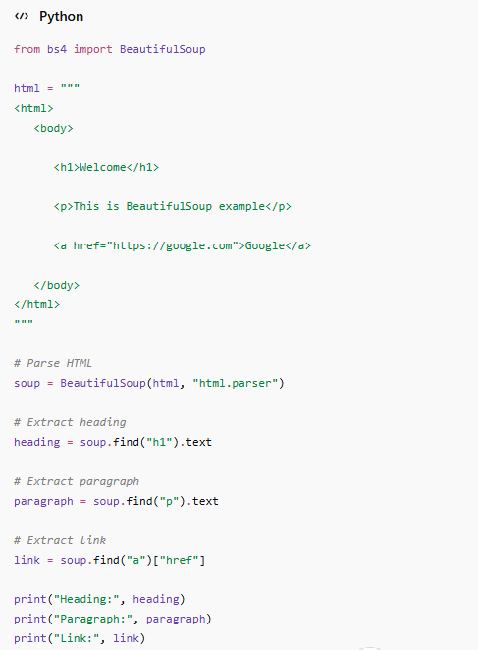

2. Complete Example — BeautifulSoup with XML

This example extracts:
- employee names
- roles

from XML.

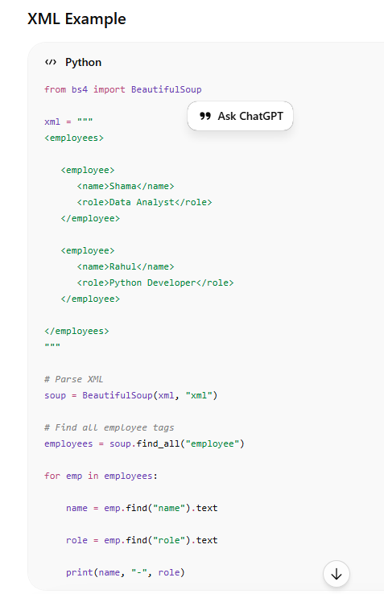

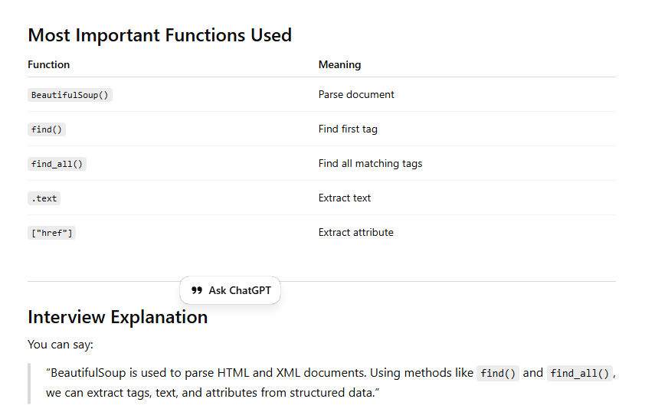

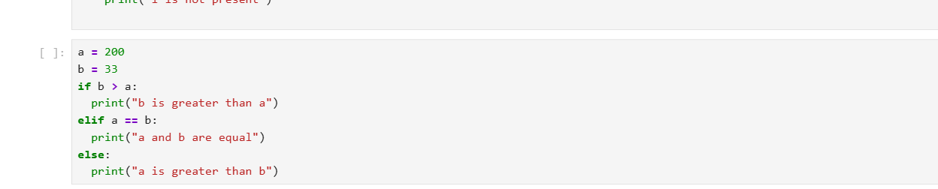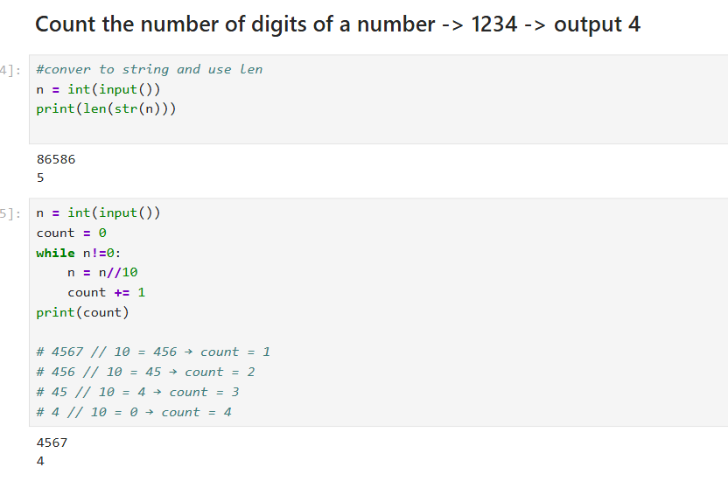
Deep Learning: It works with unstructured data like text, image, audio, video.

- what is difference between NumPy & pandas & how have you used it?
NumPy is mainly used for numerical computations and works with arrays, while Pandas is used for data manipulation and works with structured data like tables (Data Frames).
NumPy is faster for mathematical operations, whereas Pandas provides flexibility for data cleaning, filtering, and analysis.”
“In my projects, I used:
Pandas for data cleaning, handling missing values, filtering data, and EDA”
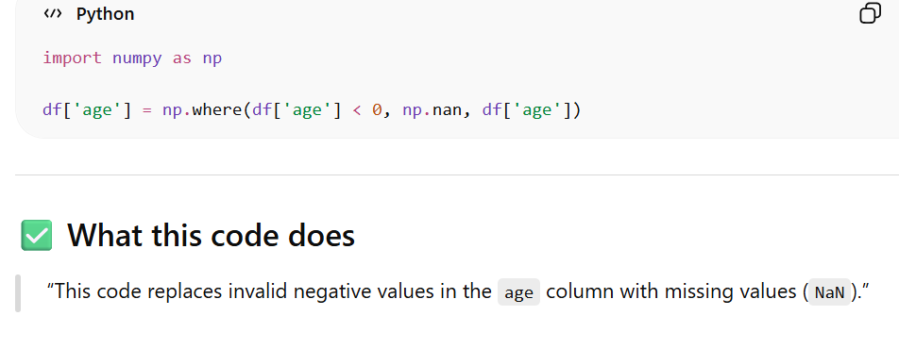
Pandas is used for handling missing values, while NumPy is used for conditional operations and replacements.”
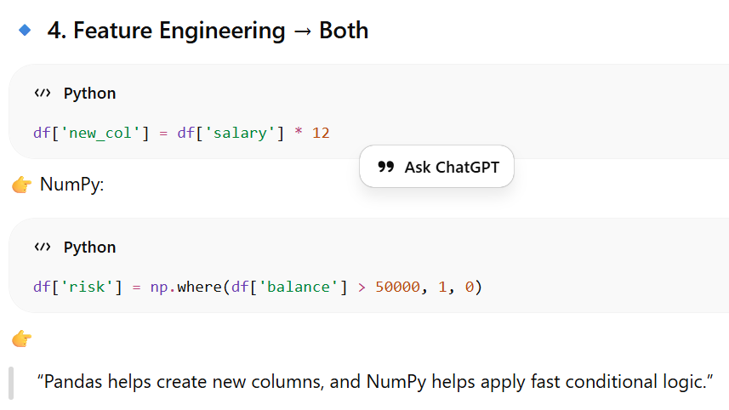
- If you are importing pandas then is it necessary to import NumPy as well?
No, it’s not mandatory to import NumPy separately because Pandas is built on top of NumPy.
However, I usually import NumPy because it provides additional mathematical functions and better control over arrays.
- How have you used scikit learn in project(egmicro credit defaulter project)?
I used Scikit-learn for the complete machine learning pipeline:
- Data splitting using train_test_split
- Model building using algorithms like Logistic Regression, Decision Tree, and Random Forest
- Model evaluation using accuracy score, confusion matrix, and ROC-AUC
- Feature selection and preprocessing where required”
  - 👉 If they ask specifically about credit defaulter:
  - “In the credit defaulter project, I used classification models to predict whether a customer will default or not based on financial and demographic features.
In my project, I used Scikit-learn for the complete machine learning workflow. I split the data using train_test_split, trained models like Logistic Regression and Random Forest, and evaluated them using accuracy, confusion matrix, and ROC-AUC. This helped me select the best-performing model

- How you decided whether the customer will churn or not?
- How you decide ,which model is best among 5 model using roc-auc curve?

- What is Python, and why is it used in data analytics?
Answer:
Python is an open source high-level, interpreted programming language with dynamic semantics known for its simplicity and readability. It is widely used in data analytics due to its extensive libraries and frameworks, such as Pandas, NumPy, Matplotlib, and SciPy, which facilitate data manipulation, analysis, and visualization. Python’s versatility allows for easy integration with other technologies, making it a preferred choice for data analysts.,
- Key Features:
  - Interpreted: Python code is executed line by line, which makes it easier to debug and test.
  - Object-Oriented: Python is designed around the concept of "objects," which are data structures that can contain both data and functions.
  - Dynamic Typing: You don't need to declare the type of a variable (e.g., integer, string) before using it.
  - Open Source: Python is free to use and distribute, and anyone can contribute to its development.

What are the key libraries in Python data analyst?
Answer:
The main libraries used in Python data analyst are:
- Pandas: Pandas is particularly useful for data manipulation, cleaning, and exploration using DataFrames, which are similar to tables in databases or Excel spreadsheets.
- Pandas is well-suited for working with tabular data, such as spreadsheets or SQL tables.
- Reading and writing data from various file formats like CSV, Excel, and SQL databases.
- NumPy: Used for numerical computing in Python. It provides support for large multi-dimensional arrays and matrices, along with a collection of mathematical functions to operate on these arrays.
- Matplotlib: Used for creating static, interactive, and animated visualizations in Python.
- Seaborn: Built on top of Matplotlib, it provides a high-level interface for drawing attractive and informative statistical graphics.
- SciPy: SciPy is a powerful Python library that builds on top of NumPy and provides additional functionality for numerical operations. Used for scientific and technical computing, including optimization, integration, interpolation, eigenvalue problems, and other linear algebra tasks.
- Scikit-learn: A machine learning library for Python that supports various supervised and unsupervised learning algorithms.

2. Can you explain the difference between NumPy and Pandas?
Answer:
NumPy (Numerical Python) and Pandas are two essential Python libraries for data analysis.
- NumPy: Primarily used for numerical computations, NumPy provides support for large, multi-dimensional arrays and matrices, along with a collection of mathematical functions. It is best suited for performing element-wise operations and linear algebra.
- Pandas: Built on top of NumPy, Pandas offers more flexible data structures like DataFrames and Series. It is used for data manipulation and analysis, allowing users to handle data with missing values, perform group operations, and more. Pandas is particularly useful for working with labeled data and data frames.

3. What is a Python dictionary, and how is it different from a list?
Answer:
A Python dictionary is an unordered collection of key-value pairs, where each key is unique and used to access the corresponding value, value can be duplicated. It is defined using curly braces {} and is mutable, meaning its contents can change over time.
In contrast, a list is an ordered collection of elements defined using square brackets []. Lists allow duplicate elements and are also mutable. The main difference between the two is that dictionaries use keys for indexing, while lists use numerical indices.
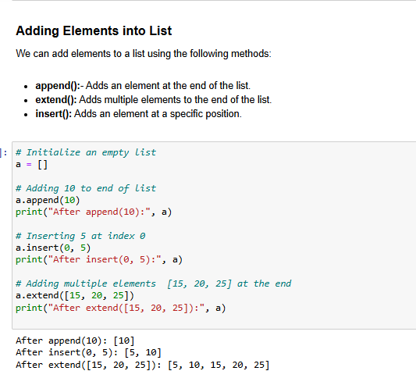
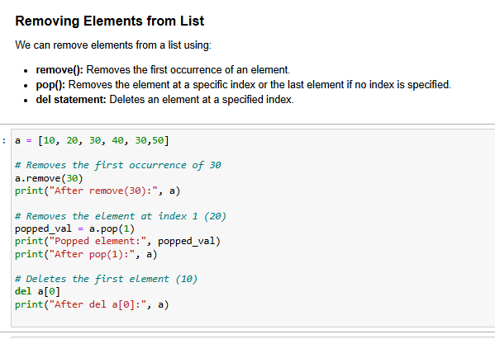

4. How would you handle missing data in a dataset using Python?
Answer:
Handling missing data is crucial in data analysis. In Python, this can be done using the Pandas library. Here are a few common methods:
- Check for missing values
- df.isnull() Returns a DataFrame of True/False indicating missing values
- df.isnull().sum()) Returns the count of missing values in each column
- Removing Missing Values: Use dropna() to remove rows or columns with missing values.
- df.dropna() # Drops rows with any missing values
- df.dropna(axis=1) # Drops columns with any missing values
- Filling/ Imputing Missing Values: Use fillna() to replace missing values with a specified value, such as the mean, median, or mode.
- Fill with a specific value (e.g., 0)
- df.fillna(0) # Fill all missing values with 0
- Fill with the mean, median, or mode:
- The median is the middle value of a data set when it is ordered from smallest to largesIf there is an odd number of values, the median is the middle value. If there is an even number of values, the median is the average of the two middle values.
- The mode is the value that appears most frequently in a data set.
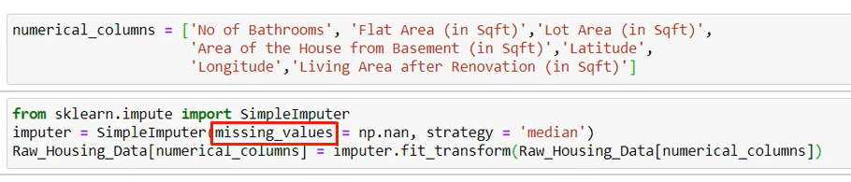

- df.fillna(df.mean()) Fill missing values with the column mean
- df.fillna(df.median()) Fill missing values with the column median
- df.fillna(df.mode().iloc[0]) # mode() returns a DataFrame, so we use .iloc[0] Fill missing values with the column mode (for categorical data)
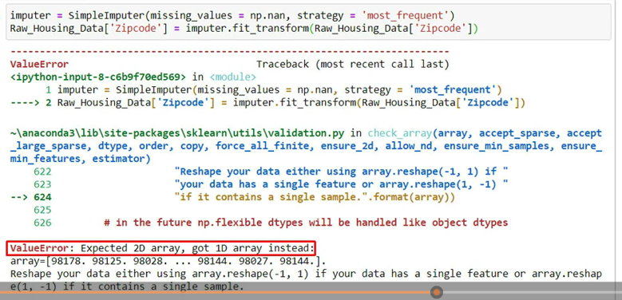
While imputing for categorical column, if we got this error
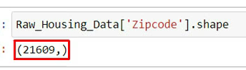
Here clearly, we can see that, column that we are passing above is single dimensional array. So, we can reshape this to avoid the error as below
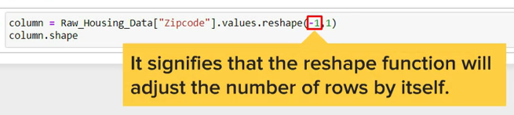
- Forward-fill (propagate the last valid value forward):
- df_ffill = df.fillna(method='ffill')
- Backward-fill (use the next valid value to fill the missing one):
- df_bfill = df.fillna(method='bfill')

Imputation: Imputing with Scikit-learn:
For more sophisticated imputation techniques (especially when you want to use machine learning methods), Scikit-learn provides an Imputer class.
- 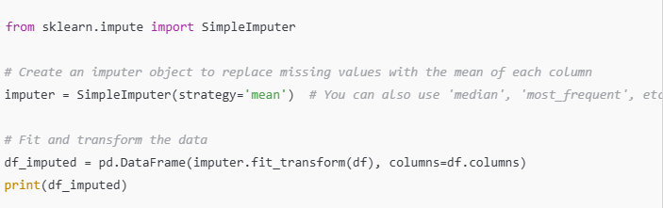5. What are Python decorators, and how are they used?
Answer:
Decorators are a powerful feature in Python that allows the modification of functions or methods without changing their actual code. They are defined using the @decorator_name syntax above a function definition. Decorators are commonly used for logging, enforcing access control, instrumentation, and caching.

6. Can you explain the concept of ‘group by’ in Pandas?
Answer:
The groupby method in Pandas is used to group data based on one or more columns. It splits the data into separate groups, applies a function to each group independently, and then combines the results. This method is particularly useful for aggregating data, such as calculating the sum, mean, or count of a grouped dataset. For example, df.groupby('column_name').sum() would sum up the values of each group. 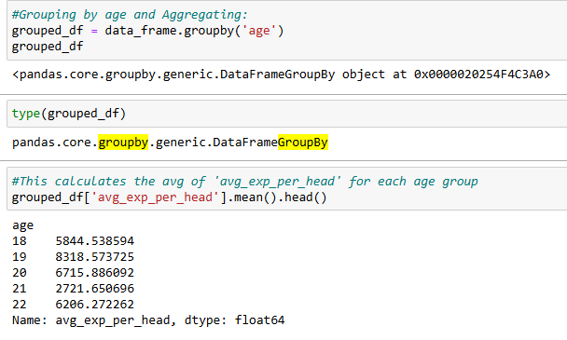

7. What is a lambda function in Python?
Answer:
A lambda function is a small anonymous function defined using the lambda keyword. It can have any number of input parameters but can only have one expression.
Lambda functions are often used for short-term tasks that do not require a full function definition.

# Lambda function to add two numbers

add = lambda x, y: x + y

print(add(5, 3)) # Output: 8

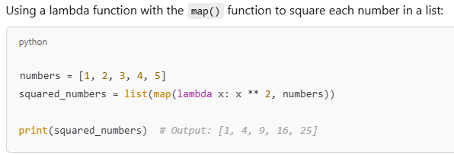

8. How do you optimize a Python code for performance?
Answer:
Optimizing Python code involves several strategies:
- Using Efficient Data Structures: Choosing the right data structures (e.g., sets for membership testing, dictionaries for lookups) can significantly speed up code.
- Avoiding Global Variables: Minimize the use of global variables as they can slow down the program.
- List Comprehensions: Use list comprehensions instead of traditional loops for creating lists, as they are faster and more readable.
- Profiling: Use profiling tools like cProfile to identify bottlenecks in the code.
- Using Built-in Functions: Leverage Python’s built-in functions and libraries, as they are optimized for performance.
Q. What is local & global variable in python?
global variables are declared outside any function and accessible throughout the program, while local variables are defined within a function and only accessible within that function.
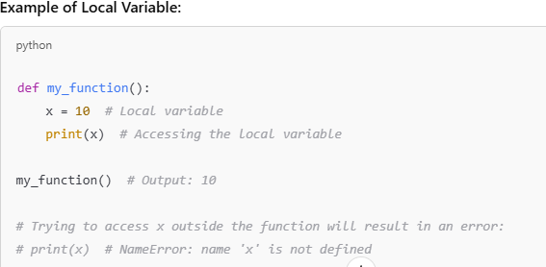
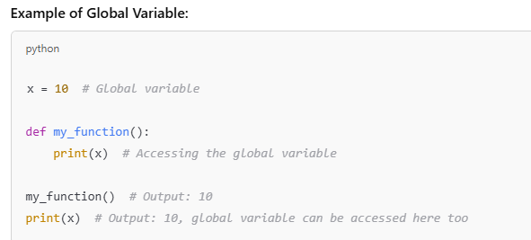

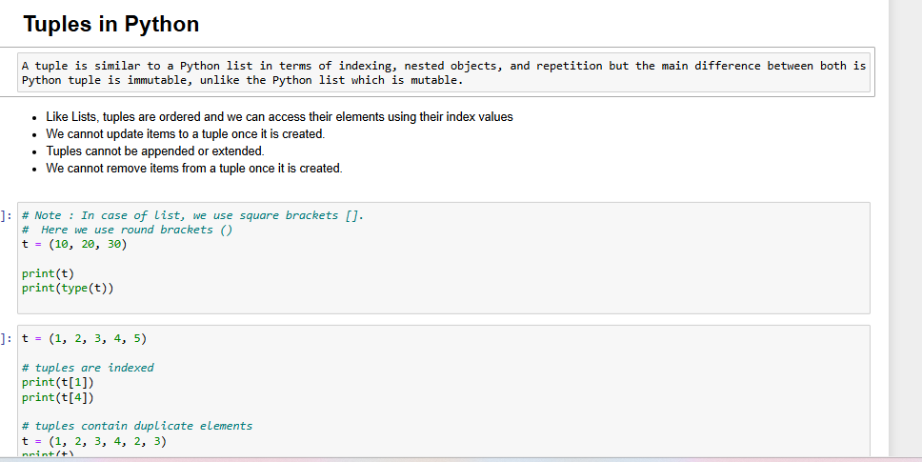

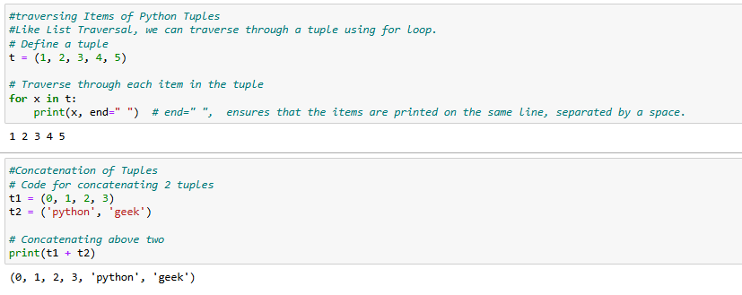

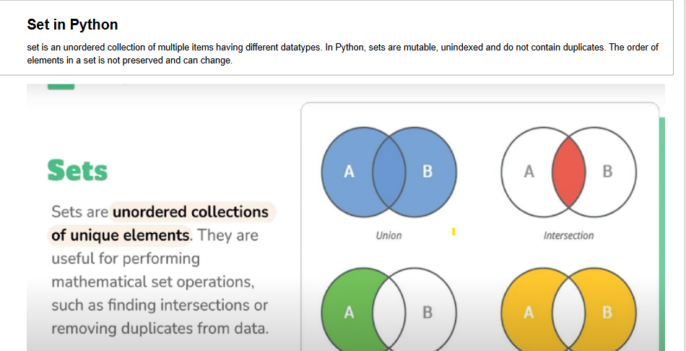

- Typecasting in Python means converting a variable from one data type to another, such as from int to float, str to int, etc.
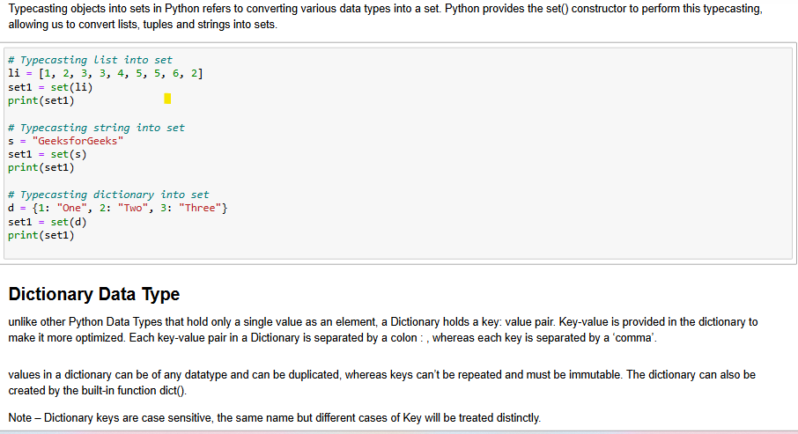

9. What is the difference between a shallow copy and a deep copy in Python?
Answer:
- Shallow Copy: A shallow copy creates a new object but does not create copies of nested objects. It only copies reference to the original objects, meaning changes to the nested objects affect both copies. It can be created using the copy() method or the copy module.
- Deep Copy: A deep copy creates a new object along with new copies of nested objects, ensuring that changes in the copied object do not affect the original. It can be created using the deepcopy() method from the copy module.

10. How would you merge two DataFrames in Pandas?
Answer:
In Pandas, merging two DataFrames can be done using the merge() function, similar to SQL joins. The function allows you to specify the type of join (inner, outer, left, right) and the key(s) to merge on. For example, pd.merge(df1, df2, on='key') merges df1 and df2 on the column key.
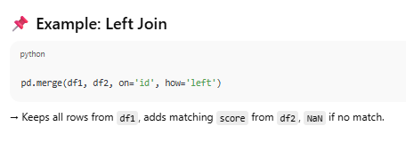

11. What is the use of the map () function in Python?
The map() function in python applies a given function to each item of an iterable (like a list, tuple, or string) and returns a new iterator containing the results, without using an explicit for loop. It is commonly used for applying a function to each element of a list. For example, map(lambda x: x*2, [1, 2, 3, 4]) returns [2, 4, 6, 8].

12. Can you explain the concept of list comprehension in Python?
List comprehension in Python is a concise and efficient way to create new lists by applying an expression to each item in an existing iterable (like a list, tuple, or range), For example, [x**2 for x in range(10)] creates a list of squares of numbers from 0 to 9.

# Using list comprehension to get even numbers
numbers = [1, 2, 3, 4, 5, 6]
even_numbers = [x for x in numbers if x % 2 == 0]

Q. Difference between list comprehension and lambda function.

List Comprehension:

Use it when you need to create a new list based on some transformation or filtering of elements from an existing iterable (like a list, tuple, or range).

Lambda Function:

Use it when you need a small, anonymous function for a simple operation that will be used only once or passed to another function (e.g., map(), filter(), or sorted()).

13. How do you handle large datasets in Python?
Answer:
Handling large datasets in Python can be challenging due to memory constraints. Some strategies include:
- Chunking: Loading data in chunks using libraries like Pandas (read_csv with the chunksize parameter) allows you to process large files in smaller pieces.
- 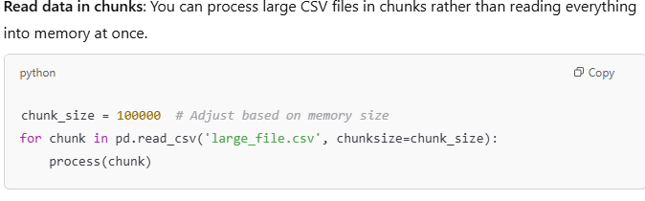

Reduce Memory Usage by Optimizing Data Types: Use efficient data types and data structures to minimize memory usage, such as using float32 instead of float64 when possible.
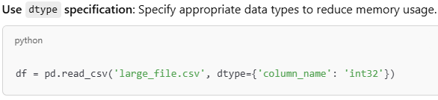

- 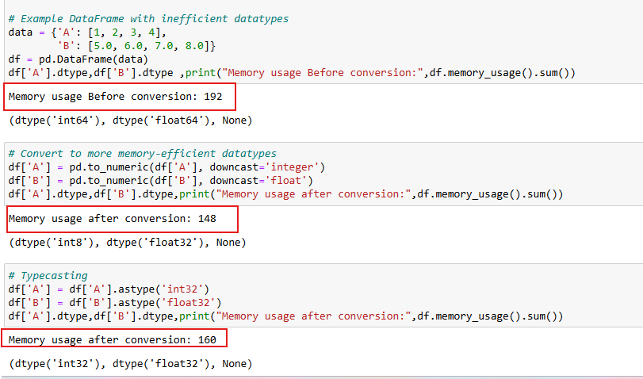

14. How would you detect and remove duplicate rows in a dataset?
Answer:
- Detect Duplicates: Use df.duplicated() to identify duplicates.
This checks for duplicate rows across the entire DataFrame
(i.e., all columns must match exactly).
- Remove Duplicates: Use df.drop_duplicates().

15. What are some common Python libraries used in data analysis?
Answer:
- Pandas: For data manipulation and analysis.
- NumPy: For numerical computations.
- Matplotlib: For data visualization.
- Seaborn: For statistical data visualization.
- SciPy: For scientific and technical computing.
- Scikit-learn: For machine learning and predictive analysis.
- Statsmodels: For statistical modeling and hypothesis testing.

16. How do you group data in Pandas and perform aggregations?
Answer: Use groupby() for grouping and aggregation:
import pandas as pd

data = {
'Category': ['A', 'B', 'A', 'B', 'A'],
'Values': [10, 20, 30, 40, 50]
}
df = pd.DataFrame(data)

# Group by Category and calculate the sum of Values
grouped = df.groupby('Category')['Values'].sum()
print(grouped)

17. What is the purpose of the groupby() function in Pandas?
Answer:
The groupby() function in Pandas is used to split data into groups based on some criteria. It is often followed by an aggregation function like sum(), mean(), count(), etc., to apply a function to each group independently. This is particularly useful for summarizing and analyzing large datasets, such as calculating the total sales for each product category.

18.You have a dataset with 1 million rows. How would you handle it efficiently?
Answer:
Read Data in Chunks: Use pd.read_csv() with the chunksize parameter.
- Use Dask: Dask is a parallel computing library in Python that helps you work with large datasets and speed up computations
- 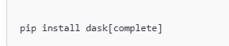
- 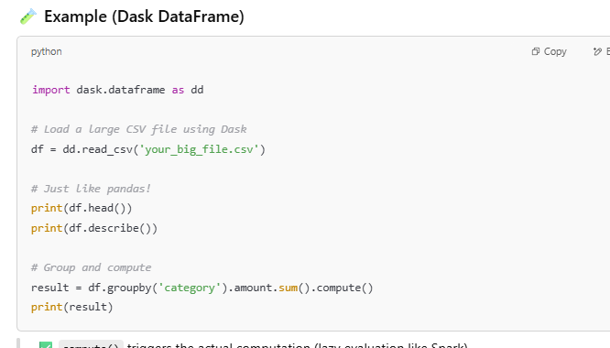
- Optimize Data Types: Convert columns to appropriate data types to reduce memory usage.
- Indexing: Use indexing for faster lookups and filtering.

20.What is the difference between ‘merge ()’, ‘join()’, and ‘concat()’ in Pandas?
merge(): merge() is used to combine two DataFrames based on a common column (or index), similar to SQL joins (like inner join, outer join, left join, and right join).
It allows you to specify how you want to merge (inner, outer, left, or right) using the how parameter.
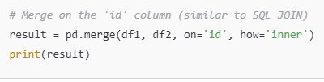
join(): join() is used to combine two DataFrames based on the index or a column. It is more convenient when working with DataFrames that share the same index, or when you want to join on indices directly. Join on index: The join is done based on the index (default behavior of join()).
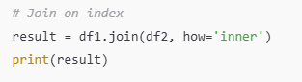
concat(): concat() is used to combine two or more DataFrames along a particular axis (either rows or columns). It doesn't require a common column or index for merging like merge() or join().You can specify the axis with the axis parameter: axis=0 for rows (default) and axis=1 for columns. ignore_index: If True, it resets the index in the resulting DataFrame.
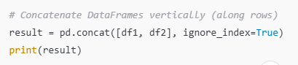

22.What is the difference between a Python list and a NumPy array?
- Data Type: A list can store elements of different data types, including integers, strings, floats, or even other lists. Array stores elements of the same data type. This uniformity allows NumPy to perform operations efficiently on large datasets.
- Operations: NumPy supports vectorized operations, whereas lists require explicit loops for element-wise operations.
- Dimensionality: A Python list can be a 1D collection (a simple list), or it can be a nested list (for multi-dimensional data), handled manually. NumPy supports multi-dimensional arrays (1D, 2D, 3D, etc.) natively. It provides powerful tools for handling and manipulating data in various dimensions (like matrices or higher-dimensional arrays).

24.Explain the difference between ‘apply()’, ‘map()’, and ‘applymap()’ in Pandas.
Answer:
- apply(): Used for applying a function along an axis (rows or columns) of a DataFrame.
- map(): Used for element-wise operations on a Pandas Series.
- applymap(): Used for element-wise operations on a DataFrame.
- 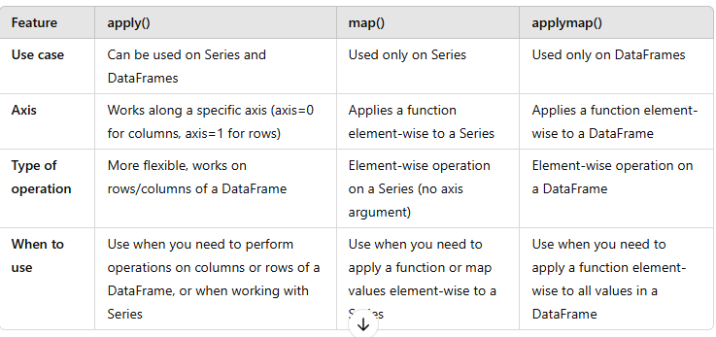
## Slicing
Slicing in Python refers to extracting a portion of a sequence like a list, string, or tuple by specifying the start and end indexes. The syntax for slicing is string[start:end], where start starting index and end is stopping index (excluded).
- Sequence Data Types
- Python String: Python treats anything inside quotes as a string. This includes letters, numbers, and symbols. Python has no character data type so single character is a string of length 1.

Multi-line Strings

s = """I am Learning

Python String on GeeksforGeeks"""

- Strings in Python are immutable. This means that they cannot be changed after they are created. If we need to manipulate strings then we can use methods like concatenation, slicing, or formatting to create new strings based on the original.
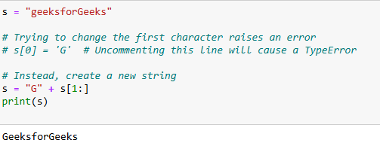
--------------------------------------------------------------------------------------------
- 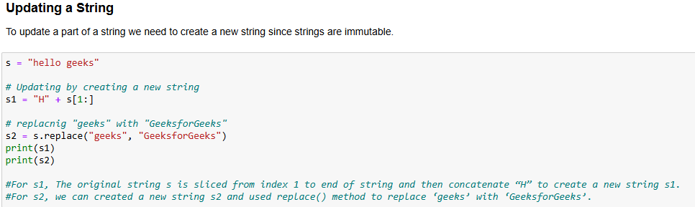
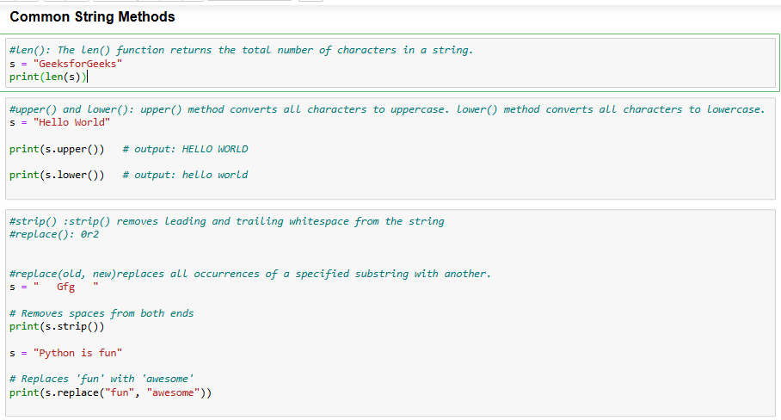
******************************************************************.
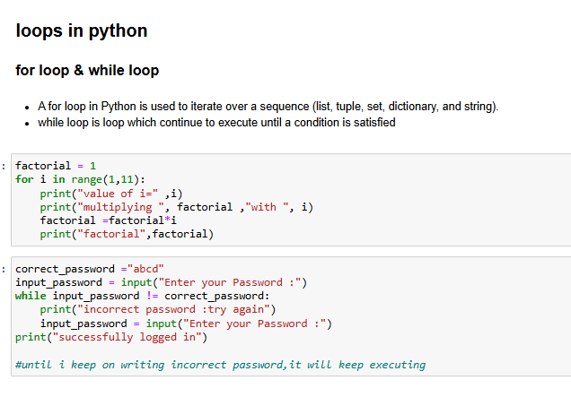

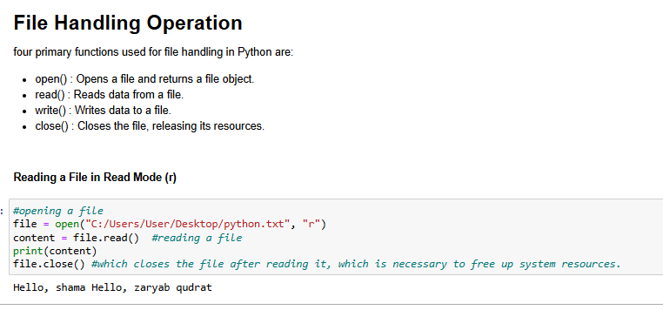

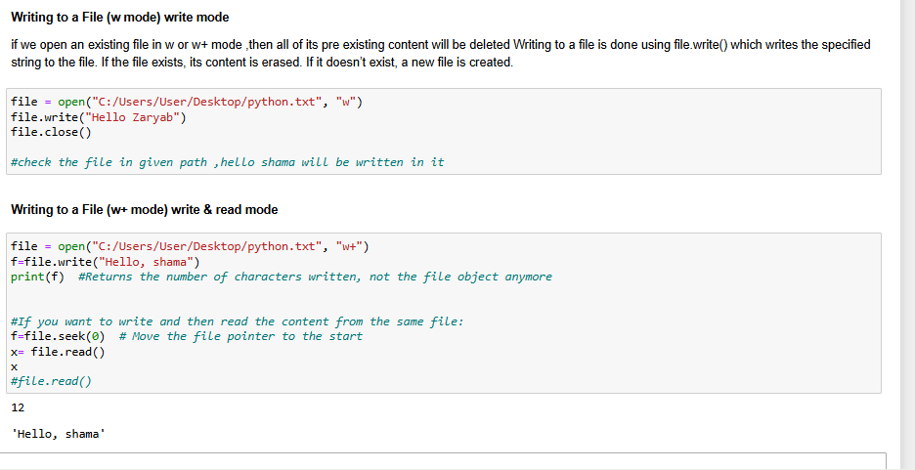

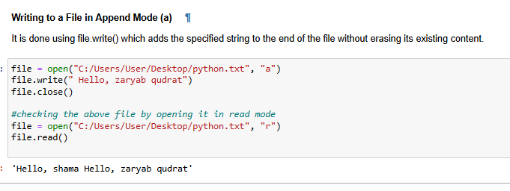
*****************************************************************.
OUTLIERS IN machine learning
Outliers are values in your dataset that are unusually high or low compared to the rest of the data. They can distort your model's performance, so it's important to detect and handle them properly.
- Detecting Outliers Using Z-score (Standard Deviation)
The Z-score measures how far a data point is from the mean in terms of standard deviations.
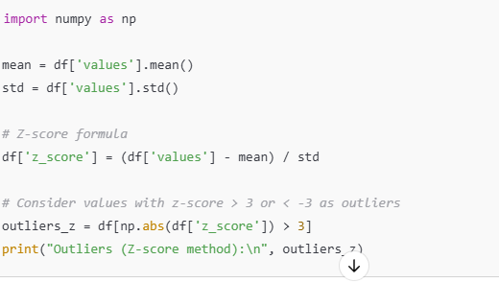
Z-score method uses -3 to +3 as the threshold for detecting outliers because of how data behaves in a normal distribution.
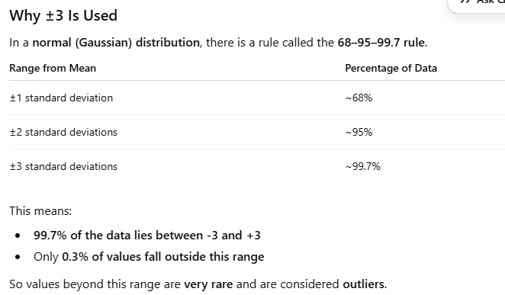
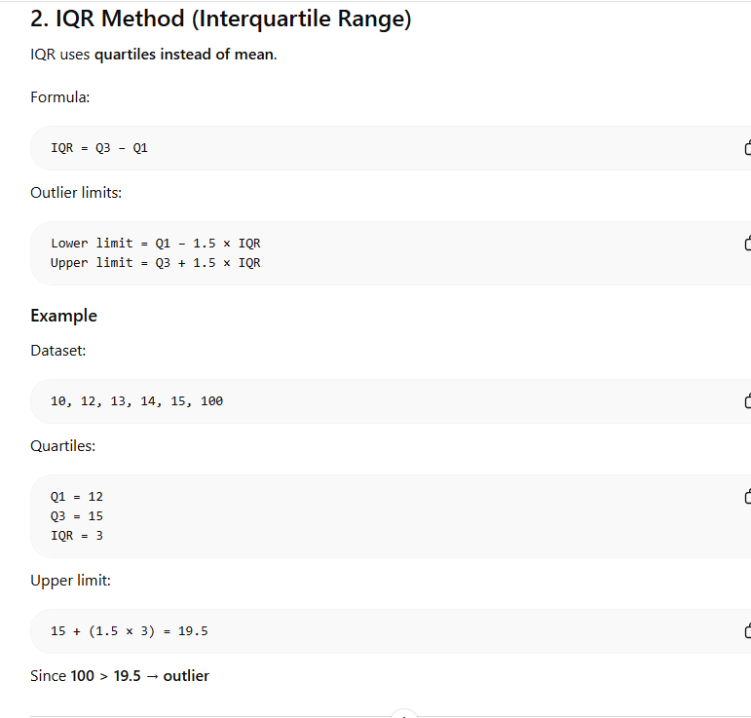
Situation | Method
Normally distributed data | Z-score
Skewed data | IQR
Small dataset | IQR
Extreme values present | IQR
Z-score and IQR are both methods to detect outliers. Z-score measures how many standard deviations a value is from the mean and works well for normally distributed data. IQR uses quartiles and is more robust for skewed distributions.
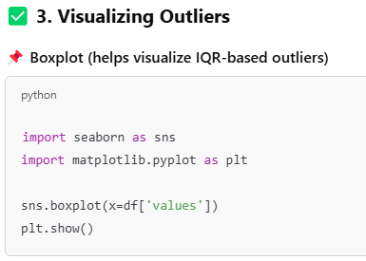
*********************************************************.
- understand the basic statistics of your dataset
In machine learning, df.describe() is a very useful tool during the exploratory data analysis (EDA) phase. It helps you quickly understand the distribution and spread of your numeric data,which is crucial for identifying outliers, skewness, and how the mean and median compare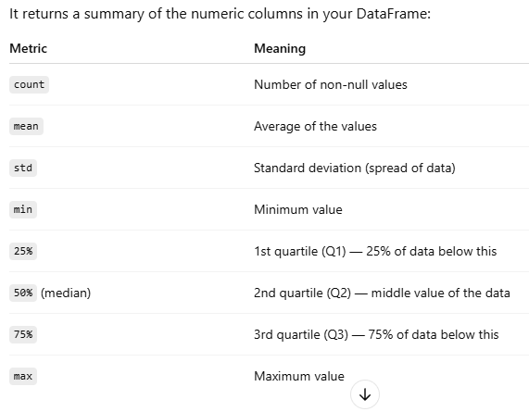

• Outliers are values that are far from the rest of the data.
• Check for large gaps between 75% and max, or min and 25%.
Skew Type | Mean vs Median | Outlier Direction | Outliers Present?
Positive Skew | Mean > Median | High/right side | Likely (e.g., large values)
Negative Skew | Mean < Median | Low/left side | Likely (e.g., very small values)
No Skew | Mean ≈ Median | Symmetric | Possibly none or balanced

*****************************************************************..
- ERROR METRIX IN MACHINE LEARNING
In machine learning, error metrics help us measure how well a model performs — they tell us how far off our predictions are from the actual values.
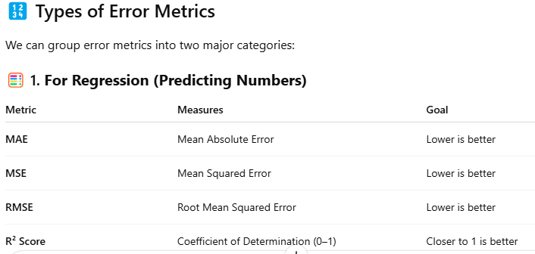

MAE (Mean Absolute Error): The average of the absolute differences between the actual and predicted values.
It tells you how far off your predictions are on average.
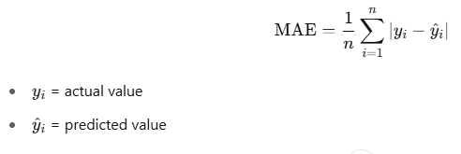

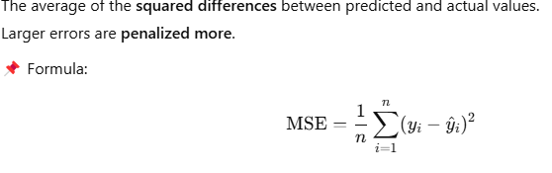

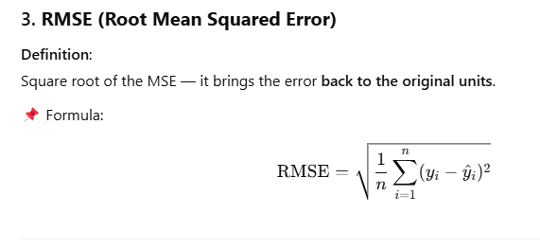

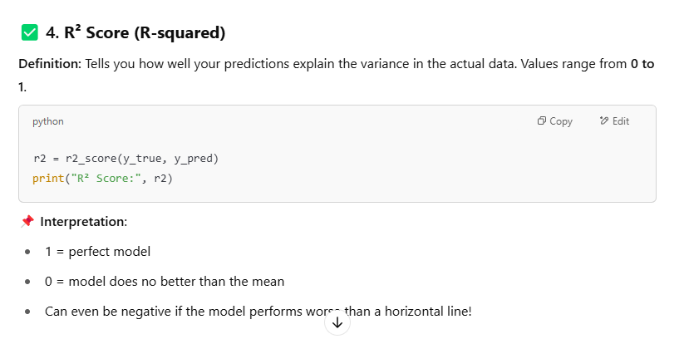
In machine learning, the R² score, also known as the coefficient of determination, is a metric used to evaluate the goodness of fit of a regression model. It quantifies how well the model's predictions align with the actual data, ranging from 0 to 1. A higher R² score indicates a better fit, meaning the model explains a larger proportion of the variance in the dependent variable.
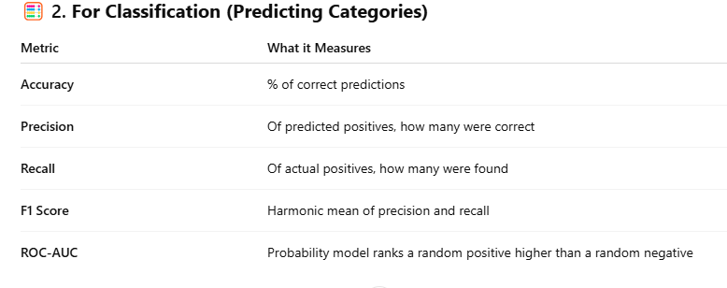

******************************************************.
MULTICOLLINEARITY
Multicollinearity refers to high correlation between independent variables in a regression model, making it difficult to determine the individual effect of each variable on the outcome. The Variance Inflation Factor (VIF) is a measure used to detect and quantify the severity of multicollinearity. A VIF greater than 5 indicates moderate multicollinearity
For multicollinearity & vif ,see below path
C:\Users\User\Downloads\Internshala\Machine Learning\Linear Regression\M5 project

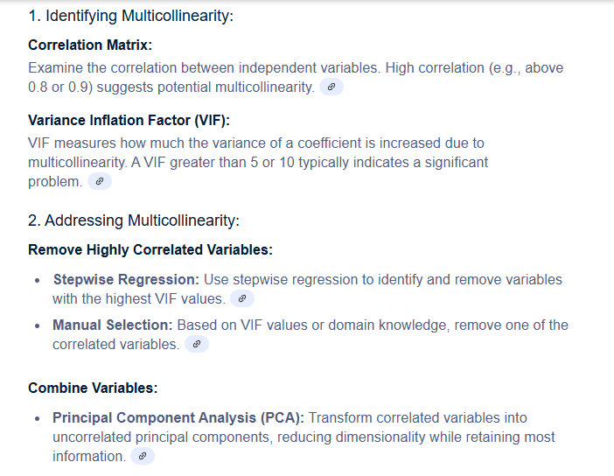

****************************************************************.

PCA (Principal Component Analysis)?
PCA (Principal Component Analysis) is a powerful unsupervised machine learning technique used for:
- Dimensionality reduction
- 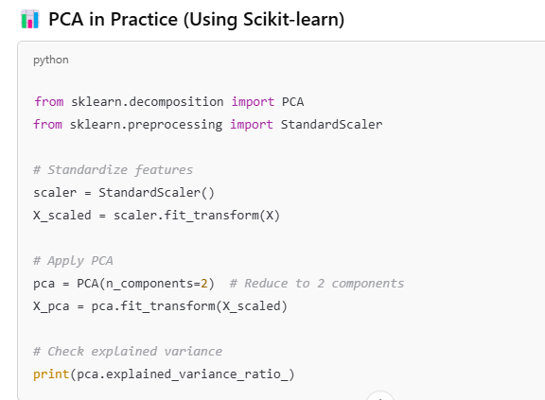

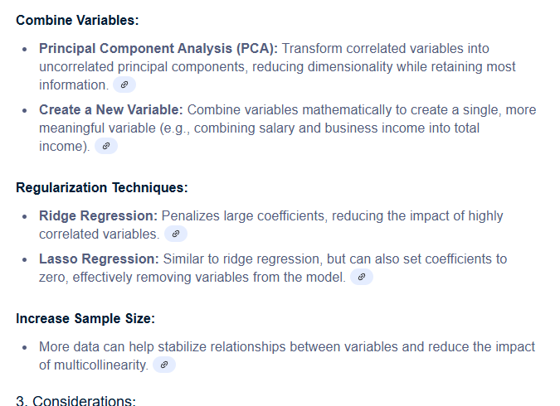

Why PCA is Called Unsupervised?
PCA does not use target/output labels. It works only on input features and identifies patterns based on variance.

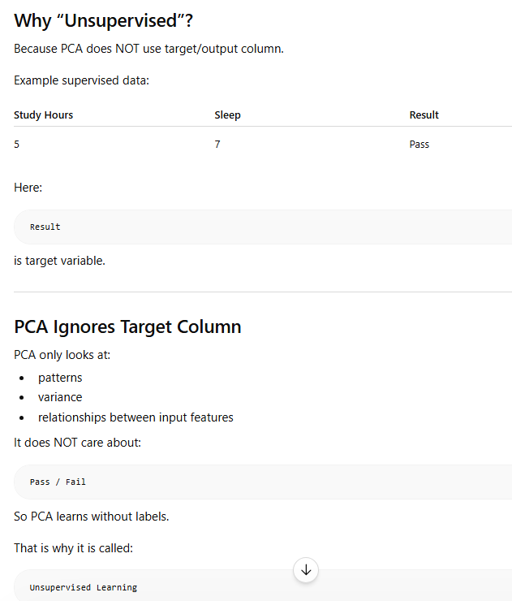

PCA Workflow
  - Standardize Data
2. Calculate Covariance Matrix
3. Find Eigenvectors and Eigenvalues
4. Select Principal Components
5. Transform Data

Advantages of PCA
- Reduces dimensions
- Faster model training
- Removes noise
- Reduces overfitting

Applications of PCA
- Image Compression
- Data Visualization
- NLP
- Noise Reduction

Why do we standardize data before PCA?
- PCA is sensitive to scaling:
PCA is variance-based. Features with larger scales have larger variance and dominate the principal components. Standardization ensures all features contribute equally by bringing them to the same scale
What is Eigenvector in PCA?
Eigenvector represents the direction of maximum variance in the data.

What is Eigenvalue in PCA?
Eigenvalue represents the amount of variance captured by an eigenvector.

Why are Eigenvalues Important?
PCA selects principal components with highest eigenvalues because they contain maximum information.

- eigenvector gives the direction of the new axis, and eigenvalue tells how important that direction is

*******************************************,*
FACTOR ANALYSIS

1. What is Factor Analysis?
Factor Analysis is a statistical technique used to reduce a large number of observed variables into a smaller number of hidden variables called factors.
The main purpose is to identify hidden relationships among variables and simplify complex datasets.
Instead of studying many variables separately, Factor Analysis groups related variables together into factors.

2. Main Idea of Factor Analysis
Suppose a dataset contains many variables that are related to each other.
Factor Analysis assumes that these variables are influenced by some hidden common factors.
Observed Variables → Hidden Factors
It reduces complexity and helps us understand the structure of data.

3. Observed Variables
Observed variables are variables that we can measure directly.
Examples:
- Height
- Weight
- Salary
- Math Marks
- Physics Marks

4. Latent (Hidden) Variables
Latent variables are hidden variables that cannot be measured directly.
Examples:
- Intelligence
- Academic Ability
- Customer Satisfaction
- Personality
We estimate latent variables using observed variables.

5. Simple Example
Suppose a student gets:
- High Math Marks
- High Physics Marks
- High Chemistry Marks
These subjects are related.
Factor Analysis may conclude that all these variables are influenced by one hidden factor called:
Academic Ability.
So instead of analyzing 3 variables separately, we analyze one hidden factor.

6. Goal of Factor Analysis
The main goals are:
- Reduce the number of variables
- Find hidden patterns
- Identify relationships among variables
- Simplify datasets

7. Steps in Factor Analysis
Step 1: Collect Data
Step 2: Standardize Variables
Step 3: Create Correlation Matrix
Step 4: Extract Factors
Step 5: Rotate Factors
Step 6: Interpret Factors

8. Step 1 – Correlation Matrix
Factor Analysis first checks correlations among variables.
If variables are highly correlated, they may belong to the same hidden factor.
Example:
Math, Physics and Chemistry marks may have high correlation.

9. Step 2 – Feature Extraction
Feature Extraction identifies important hidden factors from observed variables.
Methods used:
- Principal Component Analysis (PCA)
- Maximum Likelihood
The goal is to determine how many important factors exist in the data.

10. Role of PCA in Factor Analysis
PCA is often used during extraction to determine the number of important factors.
PCA finds directions with maximum variance.
Factors with high variance are selected because they contain more information.

11. Eigenvalues in Factor Analysis
Eigenvalue tells how much information/variance a factor explains.
Rule:
Higher Eigenvalue → More Important Factor
Usually factors with eigenvalue > 1 are selected.

12. Step 3 – Feature Rotation
After extraction, factors may be difficult to interpret.
Rotation rearranges factors to make them clearer and easier to understand.
Rotation improves interpretability.

16. Real-Life Example
Customer Survey:
- Product Quality
- Packaging
- Delivery Speed
- Staff Behavior
- Cleanliness
Factor Analysis may create:
- Product Experience
- Service Experience

20. Difference Between PCA and Factor Analysis
PCA:
- Focuses on variance
- Used for dimensionality reduction
- Creates principal components
Factor Analysis:
- Focuses on hidden factors
- Used for relationship modeling
- Creates latent variables
********************************************.*********

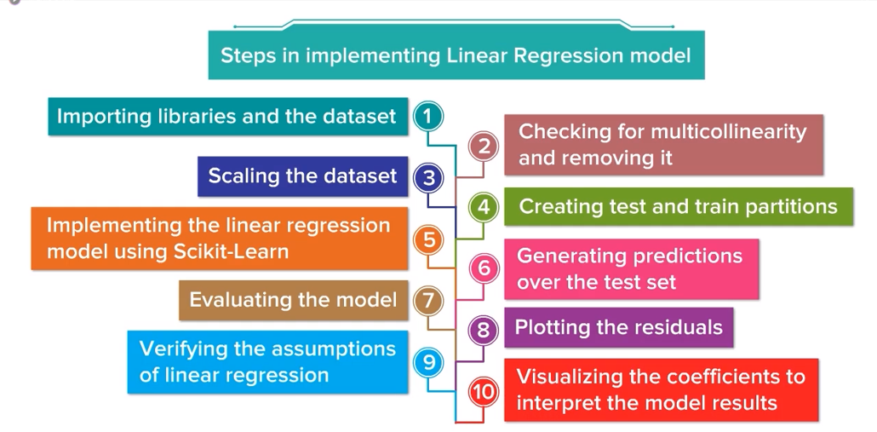
*********************************************.
IMBALANCE DATASET
An imbalanced dataset is a dataset in which target variable are not represented equally. This is a common issue in classification problems and can seriously affect model performance.

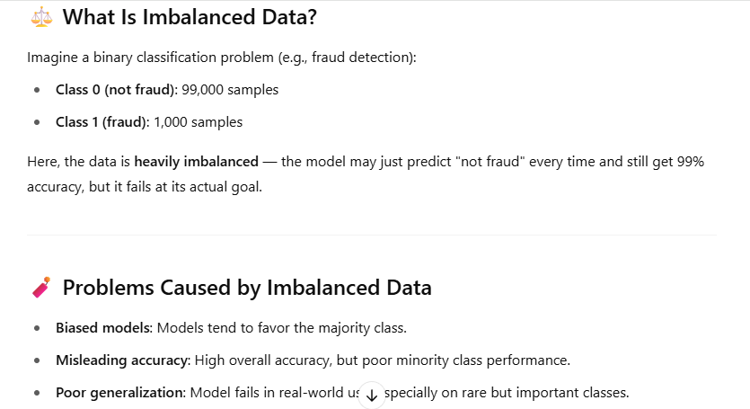

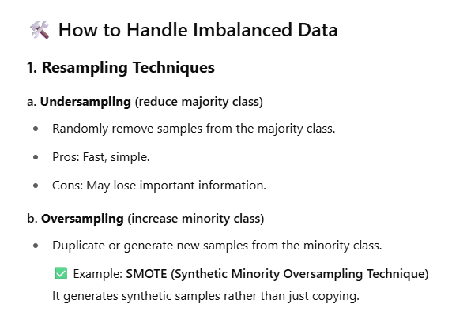
Under sampling is a technique used to handle imbalanced datasets by reducing the number of samples in the majority class so that it is more balanced with the minority class.
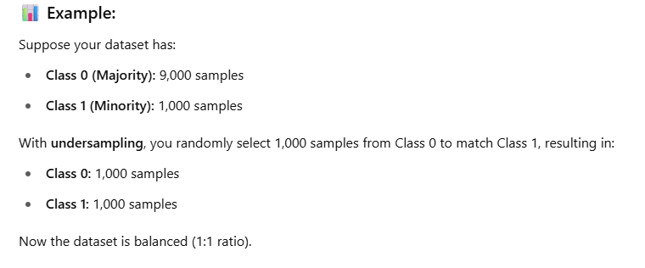
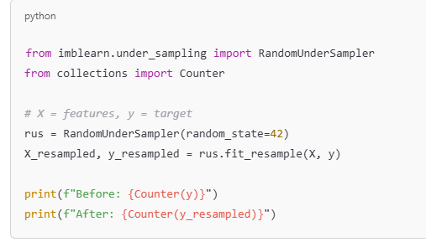

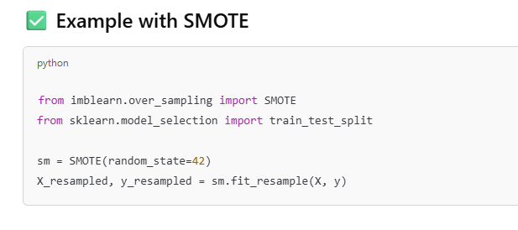
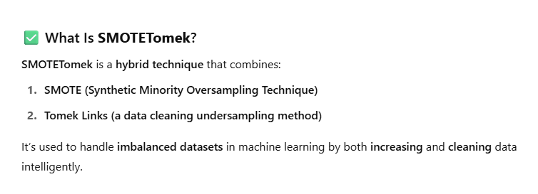
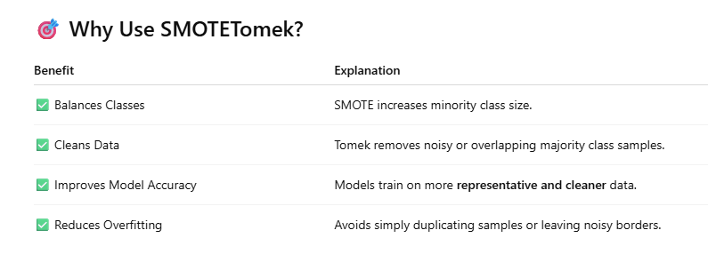
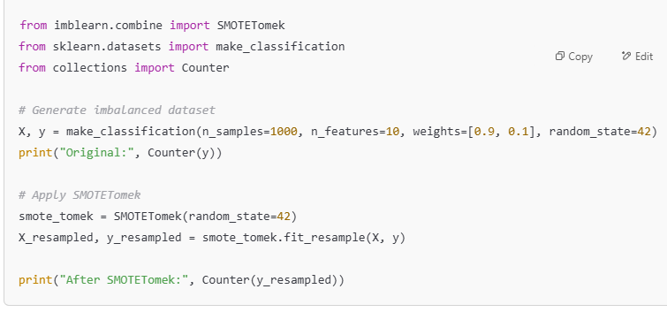
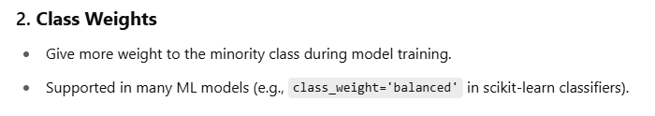
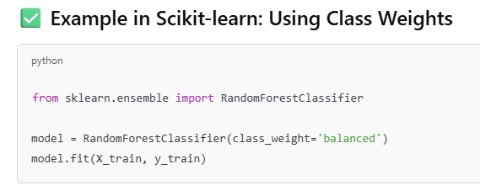
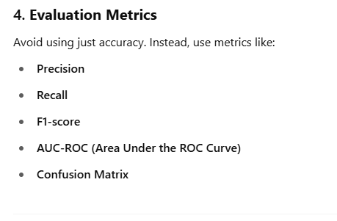
When to Use Precision in Machine Learning
You should focus on precision when you care more about the correctness of positive predictions than catching all actual positives.
Precision tells you:
👉 “Of all the instances the model predicted as positive, how many were actually positive?
Real-World Examples When to Use Precision
- It gives the parentage of false positive
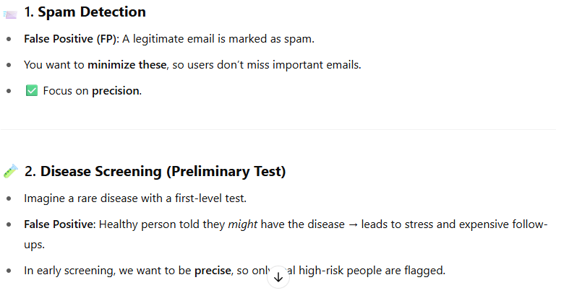
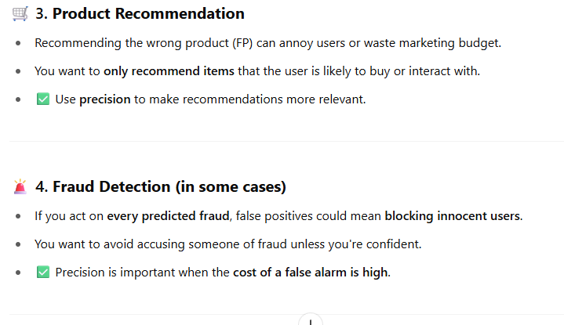
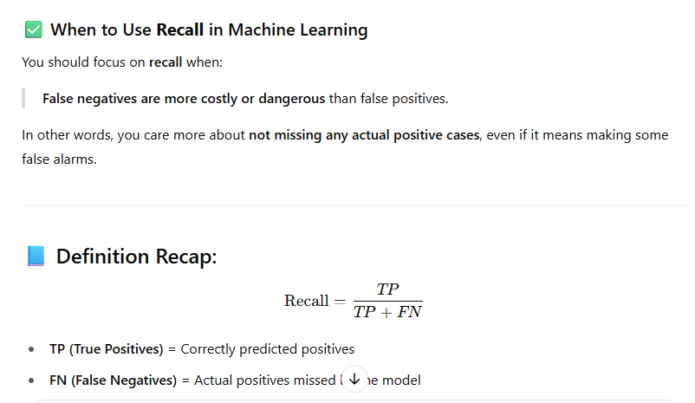
“Of all the actual positive cases, how many did the model correctly identify?”
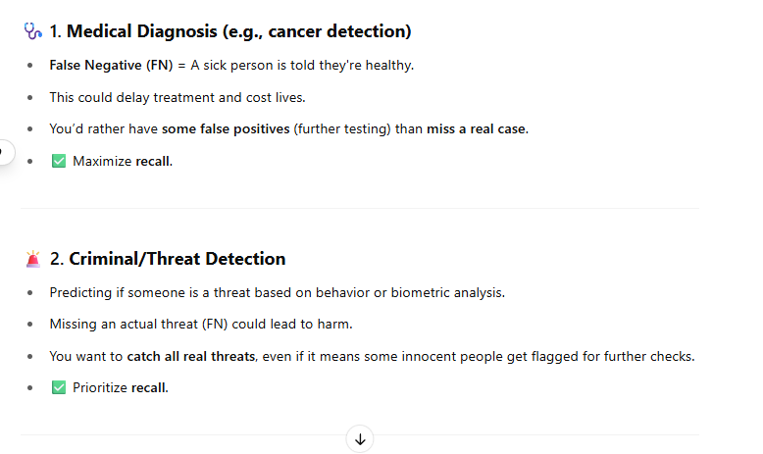
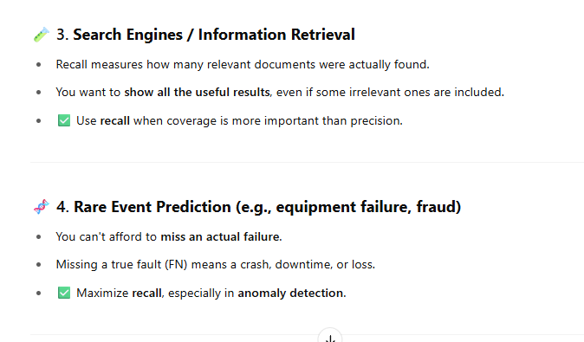
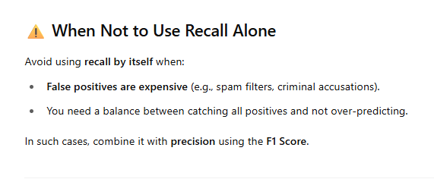
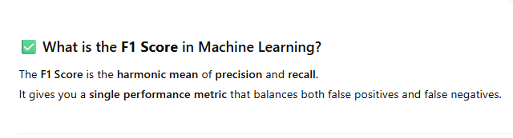
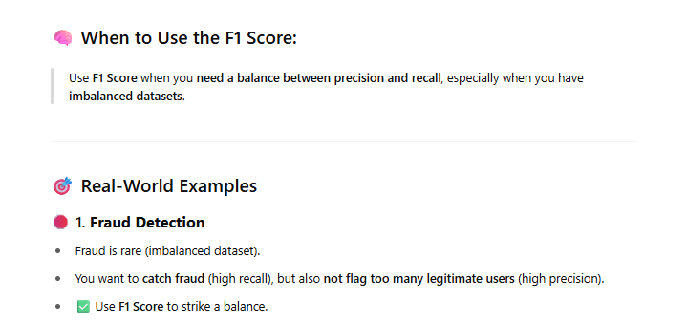
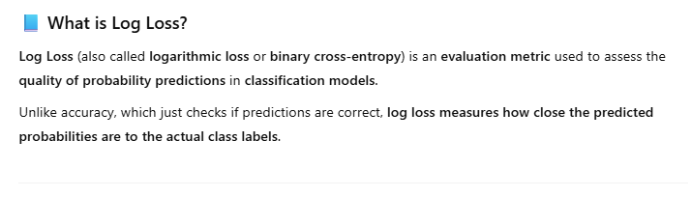
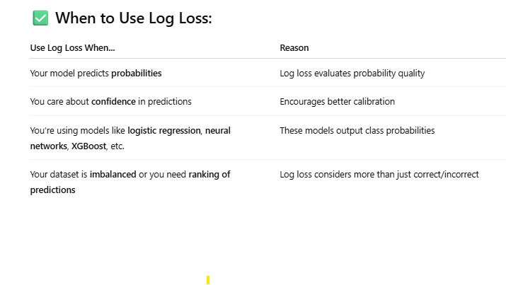
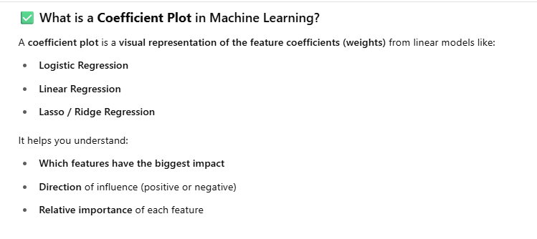
Watch internshala module 7 video for detailed explanation
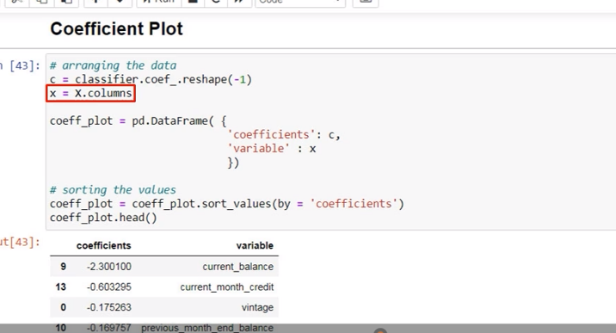

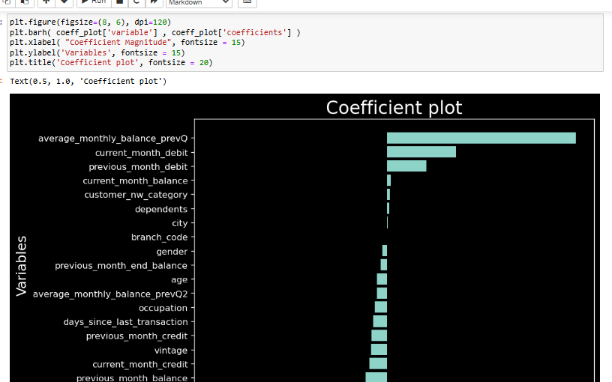

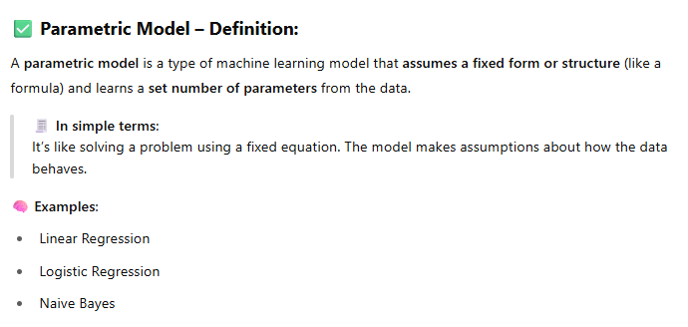
A parametric model is that model which has finite and fixed set of parameters to learn from
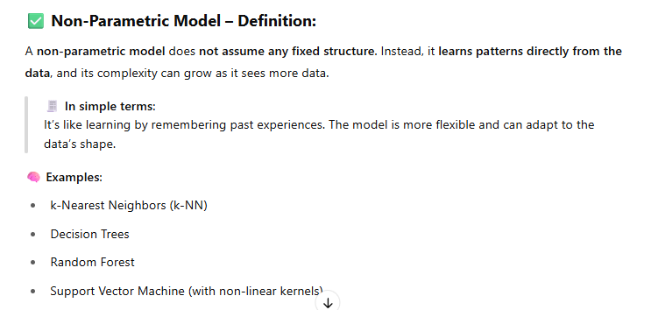
A non-parametric model is that model that keeps on learning from the data until there is nothing left to learn

- DEBUGGIN AN ERROR IN PYTHON CODE
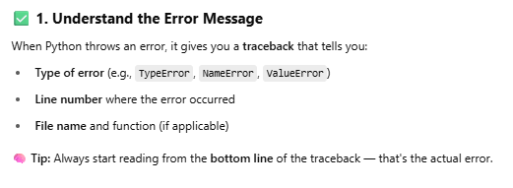
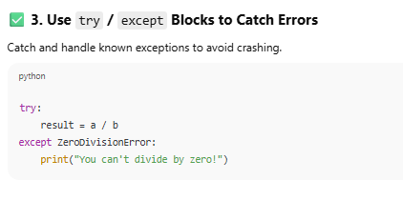
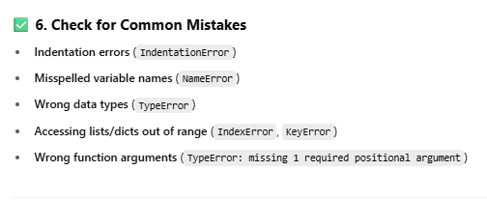
*****************************************
Feature engineering:
Rescaling Technique:
Scaling is important in machine learning to bring all features to the same scale so that the model does not give more importance to features with higher magnitude. (useful for distance-based algorithm)

Scaling is not important for Decision trees, random forest & gradient boosting algorithm because they split data based on feature thresholds rather than distance or magnitude.

1.Standardsiaton (Z score scaling): Standardization rescales data so that:
Mean = 0 and Standard Deviation = 1
Use it when data is normally distributed or if the data has outliers. We use it in most ML problems, especially with linear, distance-based, and PCA-based models.

2.Normalization (MIN-MAX scaling): Normalization rescales values into a fixed range (usually 0–1).
Use normalization when data has no extreme outliers or outliers are already handled before
Skewness:
Skewness describes the asymmetry of a data distribution. It shows whether the values in a dataset are leaning more toward the left or the right side of the distribution.
If the data is perfectly balanced, it has zero skewness (normal distribution
skewness analysis should only be applied to continuous numerical variables. Applying KDE on label-encoded categorical data produces misleading density plots because the numeric order is artificial.
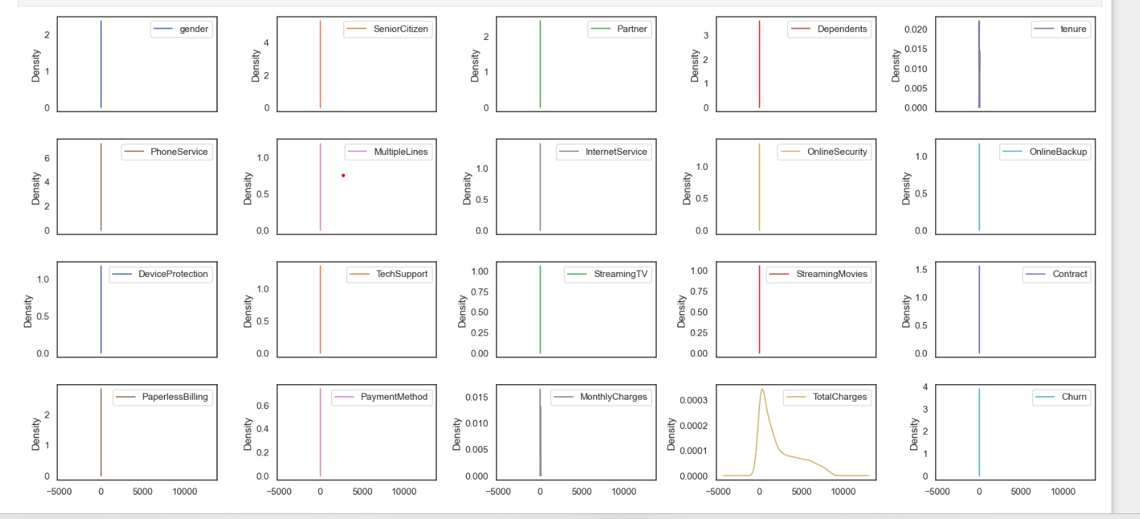
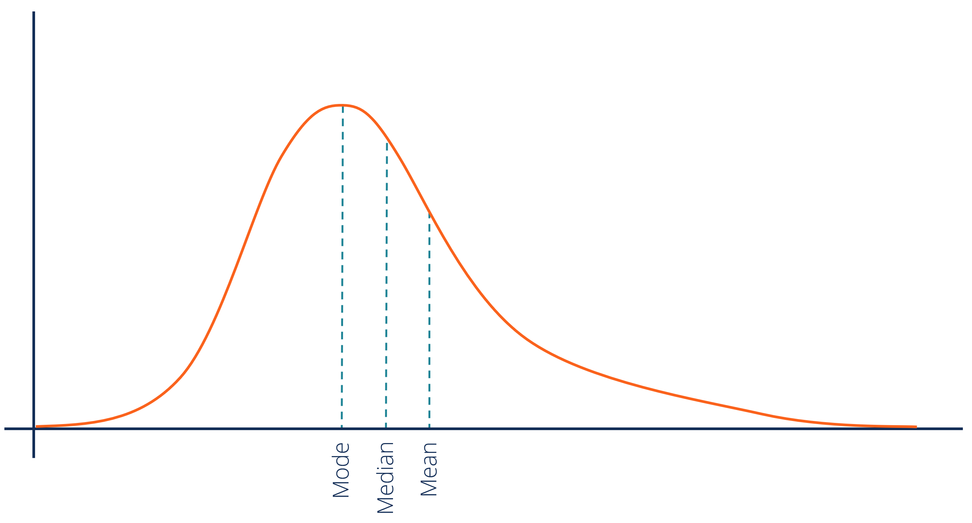
Tail is longer on the right side
Most values are small, but a few very large values exist
Example:
- Income distribution
- House prices
Key relation:
Mean > Median > Mode
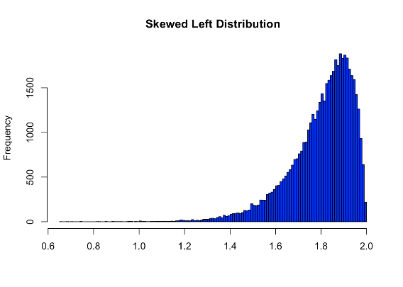
Tail is longer on the left side
Most values are large, but a few very small values exist
Example:
- Easy exam scores (many students score high)
Key relation:
Mean < Median < Mode
Skewness can be treated using transformations like square root and cube root. Square root transformation is used for moderately skewed data, while cube root transformation is useful for highly skewed data and can also handle negative values. These transformations compress large values and help make the distribution more normal.
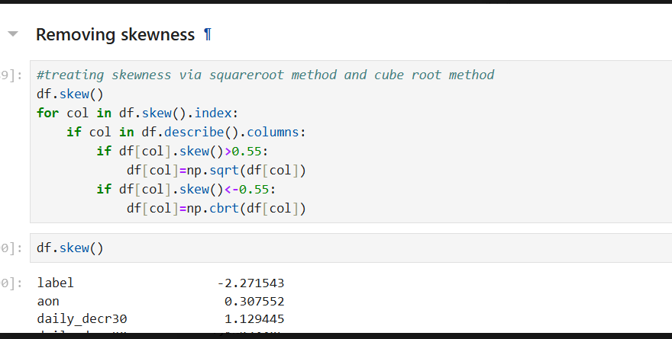
- Explain logistic regression:
- Activation function in logistics regression.
- Sigmoid function
- Cross validation score
- Optuna
- Underfitting & overfitting
Underfitting occurs when the model is too simple and cannot capture the pattern in the data, resulting in high training and testing error. Overfitting occurs when the model learns the training data too well, including noise, leading to low training error but high testing error.
- If training & testing both accuracy is low-underfitting
- If training accuracy is very high but testing accuracy is low-over fitting
- Cross validation
- ROC-AUC curve is used to evaluate binary classification models. It shows the tradeoff between true positive rate and false positive rate at different thresholds. The AUC score measures the model’s ability to distinguish between classes, where higher values indicate better performance.
- ROC-AUC curve is used when the dataset is balanced and measures the tradeoff between true positive rate and false positive rate. Precision–Recall curve is preferred for imbalanced datasets because it focuses on correctly identifying the minority class
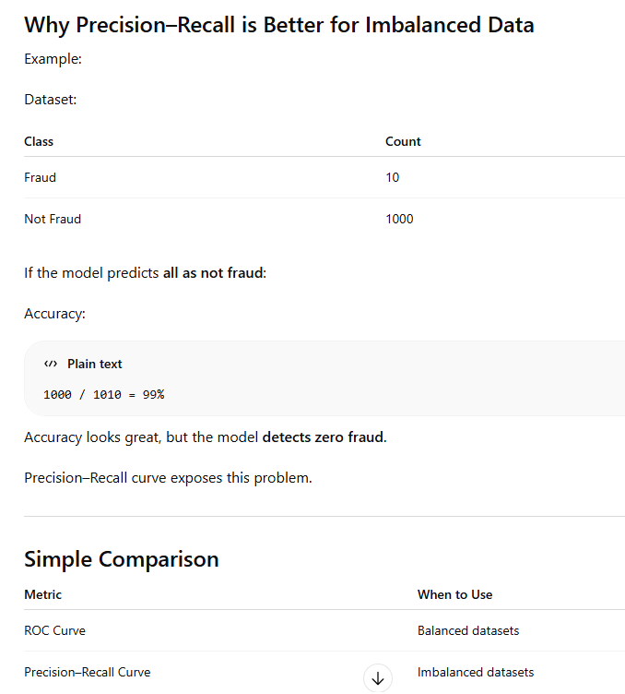
- What is Z-score?
Z-score measures how many standard deviations a data point is from the mean.
Uses:
- Detect outliers
- Standardize data

